Types of Radiation

Types of Radiation

Ernest Rutherford and Paul Villard discovered that there were three different types of emission from radioactive substances. They named these alpha (α), beta (β) and gamma γ) radiation.

Experiments showed that the alpha and beta emissions were actually particles expelled from the nucleus.

Gamma radiation was found to be high-energy electromagnetic radiation (light), also emanating from the nucleus.

These radiations were identified by passing them through a set of parallel plates with a large potential difference (voltage) across them.

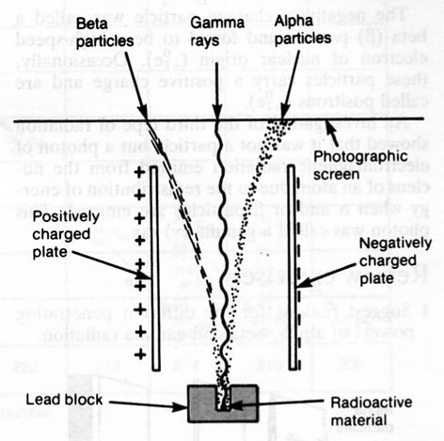

This experiment showed the following about the various radiations.

Alpha (α) particle • Positively charged (attracted to negative plate).
• Relatively large mass (takes longer to "bend" in its path).

Beta (β) particle • Negatively charged.
• Relatively light particle (its path "bends" quickly).

Gamma (γ) Ray • No charge (not deflected).
• No mass.
• Pure energy in the form of electromagnetic radiation
(light).

Properties Of Radiation

 | α | β | γ
Nature | Helium nucleus  (He-4) | Electron | Light ray
Charge | + 2 | - 1 | 0
Mass | About 4 atomic units  (quite big) | About 0.005 atomic units (tiny) | 0
Speed | Slow | Fast - nearly the speed of light | Speed of light
Penetration | Stopped by a few cm of air.  (Big and slow means lots of collisions.) | Stopped by a few metres of air, 1-2 mm of Al. | Mostly absorbed by a few cm of Pb - never completely absorbed.
Ionising Effect | Very high.  (Large size makes it easy to remove electrons from atoms.) | Small due to its small size. | Very small since it is pure energy and not a particle.

